Office of Research Compliance and Ethics
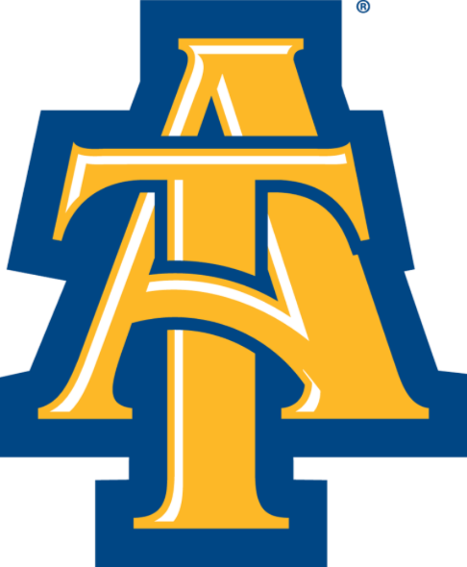
Clearance for Graduate Student Research

Instructions: Complete this form, provide a copy of your abstract and methodology ONLY, provide a copy of the compliance committee approval letter for your research (if applicable), and send all documents to rescomp@ncat.edu
Student Information
First Name
Last Name
Email
Department
Phone Number
Research Title
Research Purpose
Advisor Information
First Name
Last Name
Email
Department
Advisor’s Signature: _______________________________________________________________________________

Check any of the following used in collecting your data:
Focus groups, interviews, or surveys (IRB)
Existing data, video or audio taping (IRB)
Animal subjects (IACUC)
rDNA, biological materials, or biohazardous materials (IBC)
Radioactive materials or equipment with radiation (RSC)
Cell lines (IBC)
Nanomaterials (IBC)
For studies that involve any of the above, answer the question below:
Has your research been approved by a compliance committee (IRB, IACUC, IBC, or RSC)?

Note: for IACUC, IBC, or RSC your advisor should have an approval letter for your research.

Allow 7 business days for processing. If you have questions or concerns email rescomp@ncat.edu or call 336-334-7995.

